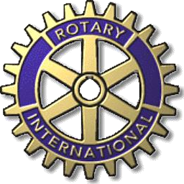
The Rotary Club of Bath, New York
PO Box 648, Bath, NY 14810
“Service Above Self”

The Bath Rotary Club offers the 2024 scholarships listed below. An applicant for any of these scholarships must not be a child or grandchild of a current Rotarian. Recipients of all scholarships will be recognized at a Scholarship Luncheon in May, and their respective school’s Award Assembly or Graduation Ceremony.
All applicants must use the 2024 application forms which were sent to the six schools eligible for scholarships, sponsored by the Bath Rotary Club.

All Scholarship applications must be submitted digitally by March 15, 2024 to Tess McKinley: tess.mckinley@gmail.com

For more information, email Elaine Tears, BRSF, Inc. Chair: ektears@gmail.com.

Dr. Frank E. Nicklaus Memorial Scholarship--$1500 (up to 3 available)
This scholarship is sponsored by the family of Frank and Rachel Nicklaus. Seniors from Avoca, Bradford, Campbell-Savona, Hammondsport, Haverling, and Prattsburgh are eligible to apply.

Ted Markham Memorial Scholarship--$1000 (up to 2 available)
This scholarship is sponsored by the family of Ted Markham. Seniors from Avoca, Bradford, Campbell-Savona, Hammondsport, Haverling, and Prattsburgh, entering environmental studies, agricultural studies, or a related field, are eligible to apply.

Vern Woolston Memorial Scholarship--$1000

(only 1 available)
This scholarship is sponsored by John Gould in memory of Vern Woolston. Only Haverling seniors, entering the field of social work or human services, are eligible to apply.

Bath Rotary Club Scholarship--$500

(up to 3 available)
Seniors from Avoca, Bradford, Campbell-Savona, Hammondsport, Haverling, and Prattsburgh are eligible to apply.

Interact Scholarship--$500

(up to 2 available)
Haverling Seniors who are members of the Interact Club are eligible to apply.
Bath Rotary Student Fund, Inc.
Board of Directors

Updated 11/27/2023

